Software Engineering (Practical) – Lab Manual

BCA Semester 6

List of Practicals
1. Study and Comparison of Software Process Models (Prepare a comparative table listing advantages, disadvantages, and suitable project types for each).
2. Preparation of Software Requirement Specification (SRS) Document (Analyze a given problem statement (e.g., Library Management System, College Attendance System) and create an IEEE-compliant SRS).
3. Structured vs. Object-Oriented Analysis for the Same Problem (Perform both Structured Analysis (DFD, ER Diagram) and Object-Oriented Analysis (Class Identification, Use Cases) for the same project).
4. Project Planning and Estimation (W5HH & COCOMO) (Use the W5HH principle to plan a project (Who, What, When, Where, How, how much). Perform software effort estimation using Basic COCOMO Model).
5. Risk Management and Quality Planning Report (Identify at least 5 major project risks, analyze their impact and probability, and propose mitigation strategies. Include a short quality plan covering QA and QC activities).
6. Use Case Modeling and Diagrams (Prepare Use Case Descriptions and corresponding Use Case Diagrams for the SRS developed earlier. Identify main actors, use cases, and relationships).
7. Design UML Diagrams (Class, Sequence, and Activity).
8. Software Testing – Test Case Design and Verification (Write at least 10 test cases for one module using Black Box and White Box techniques. Indicate input, expected output, and actual output.)
9. Software Testing Levels and Execution Report (Demonstrate different testing levels (Unit, Integration, System, Acceptance) conceptually using one module. Prepare a short testing report).
10. Demonstration of CASE Tools (Explore a CASE tool such as StarUML, Visual Paradigm, or Rational Rose. Demonstrate how it supports software design (UML creation, code generation, or documentation).

✅ Practical: 1 Study and Comparison of Software Process Models (Prepare a comparative table listing advantages, disadvantages, and suitable project types for each).

Aim
To study and compare various Software Process Models used in software development.

Theory
Software Process Models define the structured approach used to plan, develop, test, and maintain software systems. Choosing the right model improves project efficiency, quality, and risk management.
The commonly used software process models are:

🔹 1. Waterfall Model

Description
A linear sequential model where each phase must be completed before the next begins.
Phases: Requirements → Design → Implementation → Testing → Deployment → Maintenance.

Advantages
- Simple and easy to understand
- Well-defined stages and documentation
- Suitable for small, stable-requirement projects

Disadvantages
- No feedback loops
- Poor model if requirements change
- Late testing

Suitable For
- Well-defined projects with fixed requirements (e.g., payroll systems)

🔹 2. Incremental Model
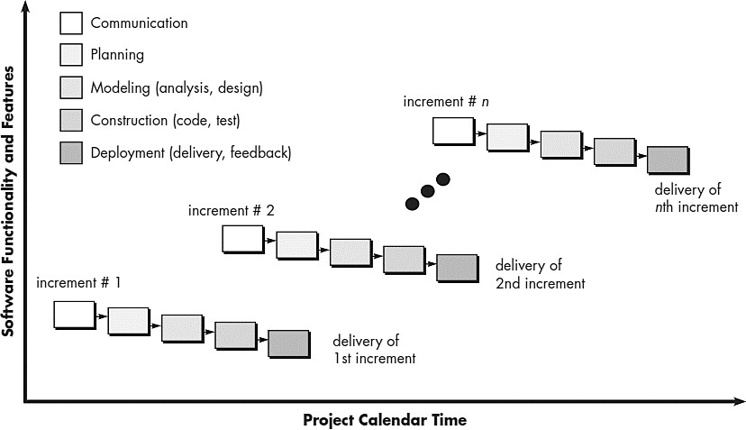

Description
Software is built and delivered in small increments. Each increment adds more functionality.

Advantages
- Early delivery of working modules
- Flexible to requirement changes
- Easier risk management

Disadvantages
- Needs good planning
- Architecture must support incremental development

Suitable For
- Medium-sized projects with partial requirement clarity

🔹 3. Spiral Model
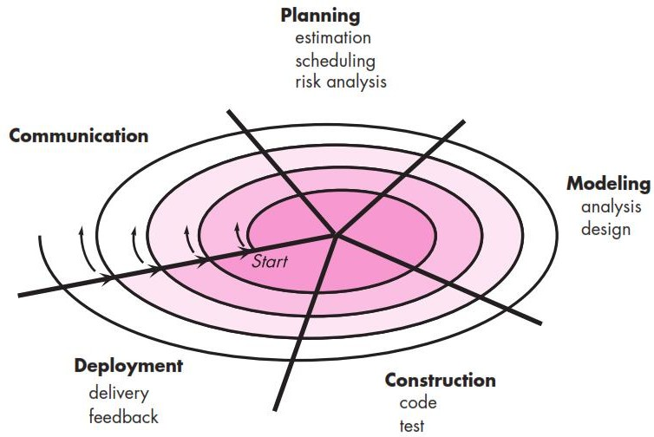

Description
Combines iterative development with systematic risk analysis. Each cycle (spiral) includes planning, risk evaluation, development, and review.

Advantages
- Best model for high-risk projects
- Frequent customer feedback
- Flexible and scalable

Disadvantages
- Expensive and complex
- Requires expertise in risk management

Suitable For
- Large, critical, and complex systems (e.g., aerospace, defense)

🔹 4. Agile Model

Description
An iterative, customer-centric approach with short development cycles (sprints). Focuses on collaboration, adaptability, and rapid delivery.

Advantages
- Highly flexible and adaptive
- Continuous feedback from customer
- Working software delivered frequently

Disadvantages
- Requires experienced team
- Documentation may be minimal
- Difficult for large distributed teams

Suitable For
- Projects with frequently changing requirements
- Start-ups and fast-evolving applications

🔹 5. V-Model (Verification & Validation Model)
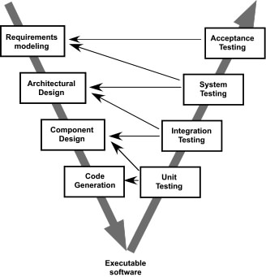

Description
An extension of Waterfall that emphasizes testing at each development stage.

Advantages
- Testing is planned early
- Highly structured and disciplined
- Suitable for safety-critical systems

Disadvantages
- Rigid and not flexible
- Requirement changes are costly

Suitable For
- Medical devices, embedded systems

📊 Comparison Table
Feature | Waterfall | Incremental | Spiral | Agile | V-Model
Requirement Flexibility | Low | Medium–High | High | Very High | Low
Risk Handling | Low | Medium | Very High | High | Medium
Customer Involvement | Low | Medium | High | Very High | Medium
Delivery | One-time | Incremental | Iterative with risk loops | Frequent Sprints | One-time
Cost | Low–Medium | Medium | High | Medium | Medium
Best For | Small stable projects | Medium projects | Large high-risk | Dynamic requirements | Critical systems

📘 Conclusion
Different software process models are suitable for different project types.
- Waterfall and V-Model are ideal for stable and safety-critical environments.
- Incremental and Agile work well when requirements evolve.
- Spiral is best when risk management is essential.
Choosing the right model improves project success, cost efficiency, and product quality.

✅ Practical: 2 Preparation of Software Requirement Specification (SRS) Document (Analyze a given problem statement (e.g., Library Management System, College Attendance System) and create an IEEE-compliant SRS).

Software Requirement Specification (SRS)

Online Food Ordering System

1. Introduction

1.1 Purpose
The purpose of this SRS document is to describe the requirements for the Online Food Ordering System (OFOS). It provides a detailed description of the functional and non-functional requirements, system features, constraints, and overall system behavior. This document will be used by developers, testers, project managers, and stakeholders.

1.2 Scope
The Online Food Ordering System allows customers to browse restaurants, view menus, place food orders, make online payments, and track delivery. Restaurant owners can manage menus, receive and process orders, and update order status. Admins can manage users, restaurants, and system-level configurations.

1.3 Definitions, Acronyms, & Abbreviations
- OFOS – Online Food Ordering System
- UI – User Interface
- DBMS – Database Management System
- OTP – One-Time Password

1.4 Overview
This document defines system features, constraints, functional and non-functional requirements, interface descriptions, and use cases for the Online Food Ordering System.

2. Overall Description

2.1 Product Perspective
The OFOS is a standalone web/mobile application designed for customers, restaurants, and administrators. It includes:
- Customer Interface
- Restaurant Dashboard
- Admin Panel
- Centralized Database

2.2 Product Functions
- User Registration & Login
- Browse Restaurants & Menus
- Add Items to Cart
- Place Order
- Payment (COD/Online)
- Order Tracking
- Restaurant Menu Management
- Admin Management

2.3 User Classes and Characteristics
User Type | Description
Customer | Places food orders
Restaurant Owner | Manages menu, accepts/rejects orders
Delivery Person | Delivers food and updates delivery status
Admin | Manages users, restaurants, system settings

2.4 Operating Environment
- Web browser / Android / iOS
- Backend: Java/Python/PHP/Node.js (any)
- Database: MySQL/PostgreSQL
- OS: Windows/Linux

2.5 Design and Implementation Constraints
- Must follow online payment security standards
- Internet connection required
- Responsive UI must be used

2.6 Assumptions and Dependencies
- User must have a valid mobile number/email
- Restaurants provide correct pricing and availability
- Payment gateway availability

3. System Features / Functional Requirements

3.1 User Registration and Login
Description: Allows users to create an account and login.
Functional Requirements:
- F1.1 User shall register using email/mobile and password.
- F1.2 System shall validate credentials during login.
- F1.3 System shall allow password recovery using OTP.

3.2 Browse Restaurants
- F2.1 User shall view a list of available restaurants.
- F2.2 User shall filter restaurants (by cuisine, rating, discount).
- F2.3 User shall view restaurant menu.

3.3 Cart Management
- F3.1 User shall add menu items to cart.
- F3.2 User shall increase/decrease quantity.
- F3.3 User shall remove item from cart.
- F3.4 System shall calculate total price.

3.4 Placing an Order
- F4.1 User shall place an order from selected restaurant.
- F4.2 User shall choose a payment method (COD/Online).
- F4.3 System shall send order details to the restaurant.

3.5 Order Processing (Restaurant Side)
- F5.1 Restaurant shall accept or reject order.
- F5.2 Restaurant shall update order status (Preparing → Ready → Out for Delivery).

3.6 Delivery Management
- F6.1 Delivery person shall view assigned orders.
- F6.2 Delivery person shall update order status (Delivered).

3.7 Admin Management
- F7.1 Admin shall manage restaurants (add/remove/update).
- F7.2 Admin shall manage users.
- F7.3 Admin shall generate system reports.

4. External Interface Requirements

4.1 User Interface Requirements
- Clean and intuitive layout
- Mobile-friendly design
- Restaurant images, dish images
- Order summary screen

4.2 Hardware Interfaces
- Mobile device or computer
- Payment gateway device (server-side)

4.3 Software Interface
- Database system
- Payment gateway APIs
- SMS/Email notification APIs

5. Non-Functional Requirements (NFRs)

5.1 Performance Requirements
- System should handle at least 1000+ concurrent users.
- Response time must be < 3 seconds.

5.2 Security Requirements
- Data encryption for passwords.
- Secure payment integration.
- Role-based access control.

5.3 Reliability
- System uptime must be 99%.
- Backup and recovery must be supported.

5.4 Usability
- Easy to use UI for both customers and restaurants.

5.5 Scalability
- System should support addition of more restaurants and users.

6. System Models

6.1 Use Case Diagram
Main Use Cases:
- Login / Register
- Browse Restaurants
- Add to Cart
- Place Order
- Track Order
- Manage Menu (Restaurant)
- Admin Controls

6.2 Data Flow Diagram (DFD)
DFD Level 0:
User → OFOS → Restaurant / Database → User
DFD Level 1 includes:
- User Module
- Restaurant Module
- Order Processing
- Payment Processing

7. Other Requirements
- System must support future integration with coupons, offers, and wallet system.
- Should support multi-language interface options.

8. Conclusion
This SRS provides a complete description of the Online Food Ordering System, including its functional and non-functional requirements, system architecture, and external interface details. It acts as a baseline for design, development, and testing.
Below are well-structured Use Case Tables for the Online Food Ordering System — suitable for practical / SRS documentation.

Use Case Tables – Online Food Ordering System

1. Use Case: User Registration
Use Case ID | UC01
Use Case Name | User Registration
Actor | Customer
Pre-condition | User must not have an existing account
Post-condition | User account is created and stored in the database
Description | User provides details to register into the system
Normal Flow | 1. User opens registration page 2. Enters name, email/phone, password 3. System validates details 4. System creates new account 5. Confirmation message shown
Alternate Flow | If email/phone already exists → show error
Exception Flow | Network failure → registration fails

2. Use Case: User Login
Use Case ID | UC02
Use Case Name | User Login
Actor | Customer
Pre-condition | User account must exist
Post-condition | User is authenticated and logged in
Normal Flow | 1. User enters email/phone & password 2. System verifies credentials 3. Login successful
Alternate Flow | Wrong password → show “Invalid credentials”
Exception Flow | Account locked after multiple failed attempts

3. Use Case: Browse Restaurants
Use Case ID | UC03
Use Case Name | Browse Restaurants
Actor | Customer
Pre-condition | User must be logged in
Post-condition | User can view restaurant list and menus
Normal Flow | 1. User selects “Restaurants” 2. System displays restaurant list 3. User applies filters (optional) 4. User selects a restaurant to view menu
Exception Flow | No restaurants found in the area

4. Use Case: Add Item to Cart
Use Case ID | UC04
Use Case Name | Add to Cart
Actor | Customer
Pre-condition | User must be logged in; menu must be loaded
Post-condition | Item added to cart
Normal Flow | 1. User selects item 2. Chooses quantity 3. System adds item to cart
Alternate Flow | If item is unavailable → system shows “Item not available”

5. Use Case: Place Order
Use Case ID | UC05
Use Case Name | Place Order
Actor | Customer
Pre-condition | Items must be present in cart
Post-condition | Order is created and sent to restaurant
Normal Flow | 1. User reviews cart 2. Selects payment method 3. Confirms order 4. System records order 5. System sends order to restaurant
Alternate Flow | Payment failed → user returns to payment page
Exception Flow | Restaurant becomes offline → order canceled automatically

6. Use Case: Accept/Reject Order (Restaurant)
Use Case ID | UC06
Use Case Name | Manage Incoming Orders
Actor | Restaurant Owner/Staff
Pre-condition | Order must be submitted by user
Post-condition | Order status updated
Normal Flow | 1. Restaurant receives new order notification 2. Restaurant accepts or rejects order 3. System updates status
Alternate Flow | If restaurant rejects → system notifies customer

7. Use Case: Update Order Status
Use Case ID | UC07
Use Case Name | Update Order Status
Actor | Restaurant Staff / Delivery Person
Pre-condition | Order must be accepted
Post-condition | Order status updated to next stage
Normal Flow | 1. Staff updates status: Preparing → Ready → Out for Delivery 2. Delivery person updates Delivered
Exception Flow | Delivery failure → system marks “Delivery Failed”

8. Use Case: Manage Menu (Restaurant)
Use Case ID | UC08
Use Case Name | Menu Management
Actor | Restaurant Owner
Pre-condition | Restaurant must be registered and active
Post-condition | Updated menu is saved in database
Normal Flow | 1. Owner adds/updates/deletes menu items 2. System updates menu database
Exception Flow | Invalid pricing or missing fields

9. Use Case: Admin Management
Use Case ID | UC09
Use Case Name | Admin Operations
Actor | Administrator
Pre-condition | Admin must be authenticated
Post-condition | System-level changes saved
Normal Flow | 1. Admin manages restaurants 2. Admin manages users 3. Admin generates reports
Exception Flow | Unauthorized access attempt blocked

10. Use Case: Track Order
Use Case ID | UC10
Use Case Name | Order Tracking
Actor | Customer
Pre-condition | User must have an active order
Post-condition | User sees real-time order status
Normal Flow | 1. User opens “Track Order” 2. System retrieves latest status 3. Status displayed to user
Exception Flow | Network issue → unable to display live status

✅ Practical: 3 Structured vs. Object-Oriented Analysis for the Same Problem (Perform both Structured Analysis (DFD, ER Diagram) and Object-Oriented Analysis (Class Identification, Use Cases) for the same project).

Structured Analysis vs. Object-Oriented Analysis (OOA)
Aspect | Structured Analysis | Object-Oriented Analysis (OOA)
Definition | Focuses on processes and data flow. It models the system using DFDs, data dictionaries, and process specifications. | Focuses on objects, their attributes, methods, and interactions. It models the system using UML diagrams like class, sequence, activity, and use case diagrams.
Primary Focus | What the system does (functions, processes). | What the system is (objects/entities and their relationships).
Key Models/Diagrams | DFD (Level 0, 1, 2), Data Dictionary, State Diagrams. | Class Diagram, Use Case Diagram, Sequence Diagram, Activity Diagram, ER Diagram.
Approach | Top-down: Starts with overall processes → decomposed into sub-processes. | Bottom-up / iterative: Starts with objects → defines interactions and behaviors.
Data Representation | Data flows between processes and stores. | Data is encapsulated in objects (attributes) along with behavior (methods).
Function Handling | Functions (processes) are central; data is secondary. | Objects are central; functions (methods) belong to objects.
Reusability | Limited; processes and functions are tightly coupled with data flow. | High; objects and classes can be reused across systems.
System Example – OFOS | - DFD Level 0 shows the system as one process.- Level 1: Processes like User Management, Order Processing, Payment, Admin.- Focus on how data moves between Customer, System, Restaurant, Admin. | - Class Diagram defines objects: Customer, Order, Restaurant, Menu, Payment, Admin.- Use Case Diagram shows user interactions.- Sequence Diagram shows message flow.- Focus on how objects interact and their responsibilities.
Advantages | - Simple to understand for small systems.- Easier to track data flow. | - Promotes modularity and reusability.- Captures both data and behavior.- Better for complex systems.
Disadvantages | - Hard to maintain for large systems.- Behavior changes require redesign. | - Can be complex for beginners.- Requires detailed modeling upfront.
Best Suited For | Systems where processes dominate and data flows are simple. | Systems where complex objects and interactions exist, like Online Food Ordering System with multiple actors (Customer, Restaurant, Admin, Delivery Person).

Example Comparison – Online Food Ordering System

Structured Analysis (DFD Approach)
- Processes: User Management, Browse Restaurants, Cart & Order, Payment Processing, Restaurant Order Handling, Admin Management.
- Data Stores: Users, Restaurants, Orders, Payments.
- Focus: Flow of information: Customer → System → Restaurant → Delivery → Admin.

Object-Oriented Analysis (UML Approach)
- Objects/Classes: Customer, Restaurant, Menu, Item, Order, Payment, Admin.
- Interactions:
  - Customer places Order → triggers Payment → Restaurant updates Order → Delivery updates Status.
- Focus: Responsibilities, behavior, and relationships of objects.

✅ Key Insight:
- Structured Analysis answers “what the system does” (process-centric).
- Object-Oriented Analysis answers “what the system is and how it behaves” (object-centric).
For modern systems like Online Food Ordering, OOA is preferred because it models real-world entities (Customer, Restaurant, Delivery) and their interactions, making maintenance, scalability, and enhancements easier.

DFD example :
  - Context Level DFD’s

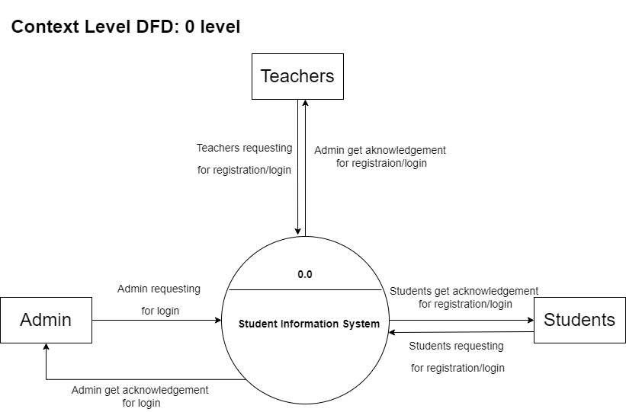
Figure 5.1.1. Context Level DFD: 0 Level

  - Level 1 DFD’s:

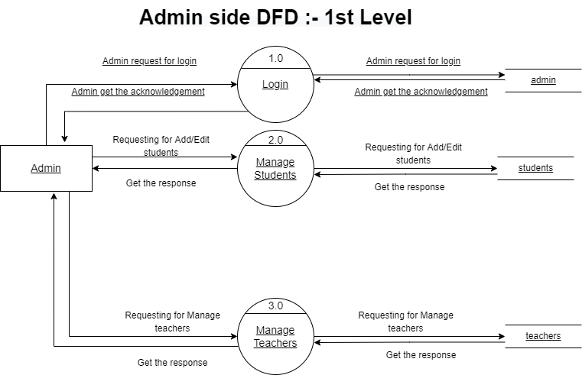
Figure 5.2.1. Admin Side DFD: 1st Level

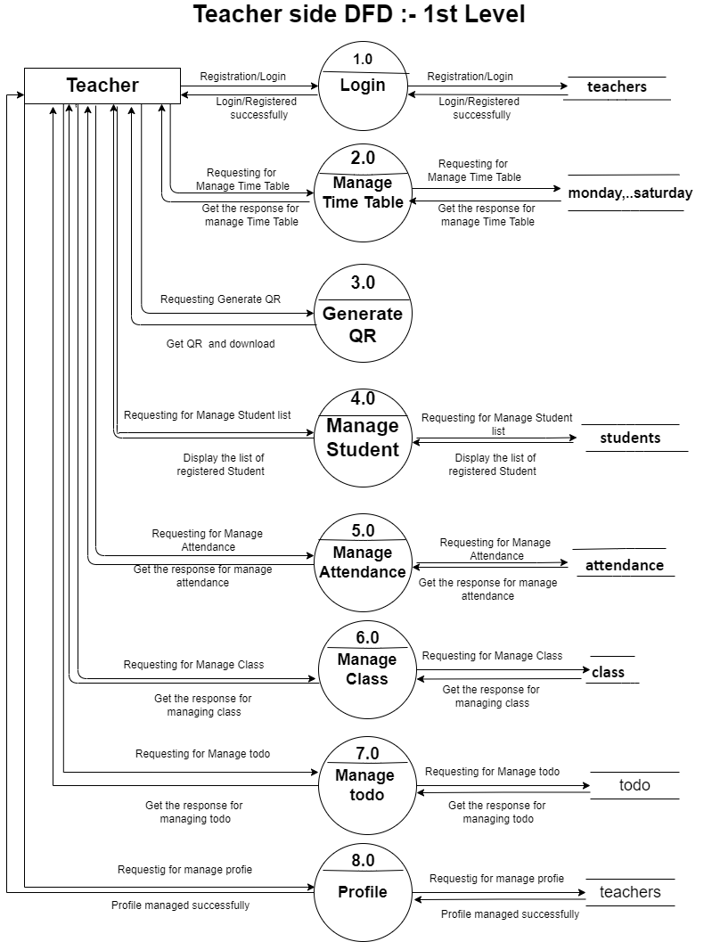
Figure 5.2.2. Teacher Side DFD: 1st Level
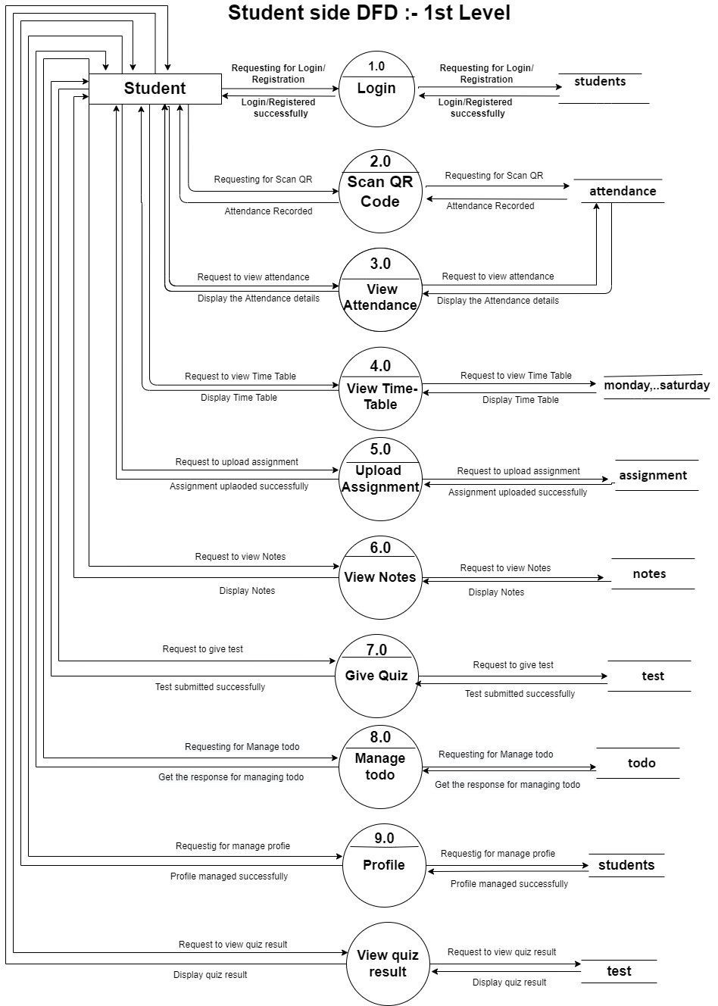
Figure 5.2.3. Student Side DFD: 1st Level
  - Level 2 DFD’s

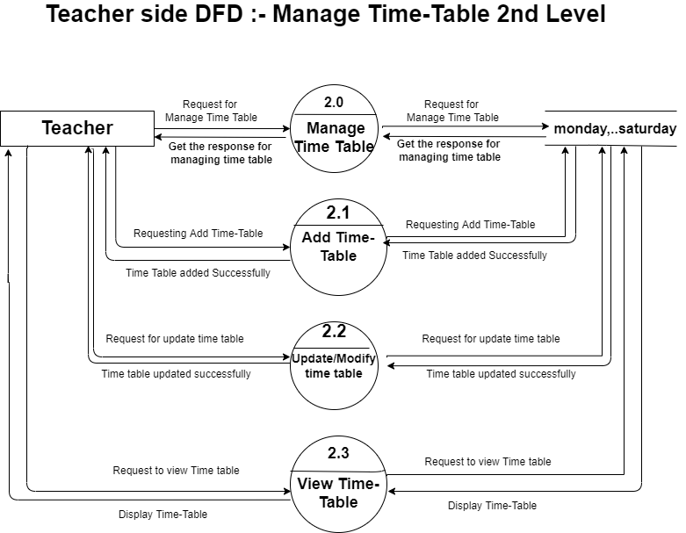
Figure 5.3.1. Teacher Side DFD: Manage Time-Table 2nd Level

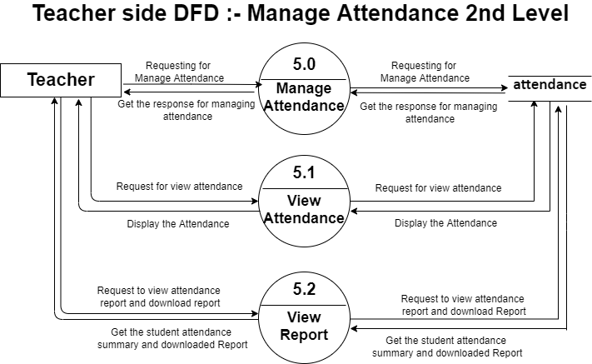
Figure 5.3.2. Teacher Side DFD: Manage Attendance 2nd Level

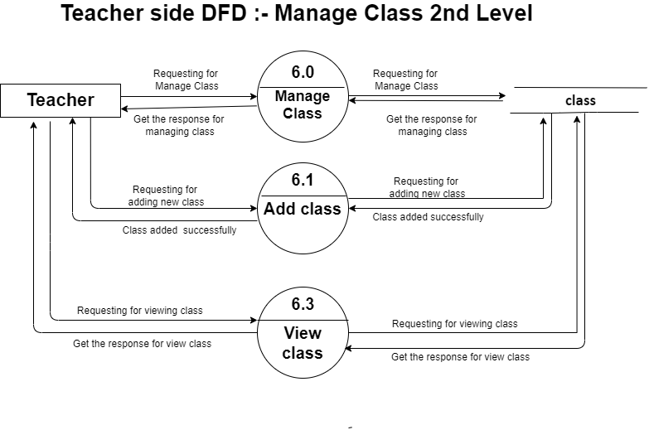 Figure 5.3.3. Teacher Side DFD: Manage Class-Table 2nd Level

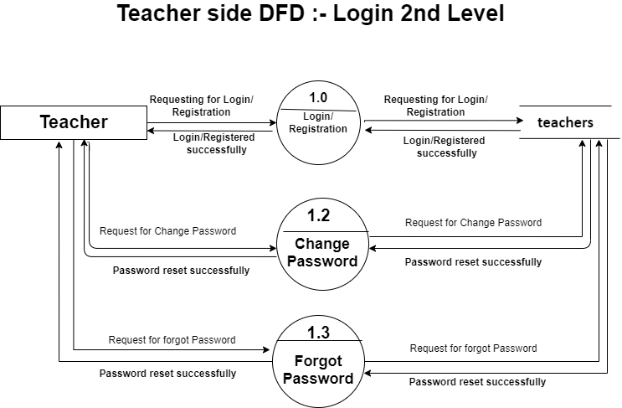
Figure 5.3.4. Teacher Side DFD: Login 2nd Level

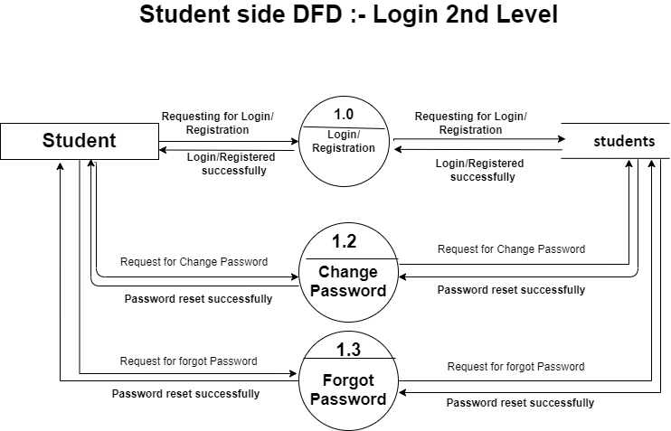
Figure 5.3.5. Student Side DFD: Login 2nd Level

  - Level 3 DFD’s:

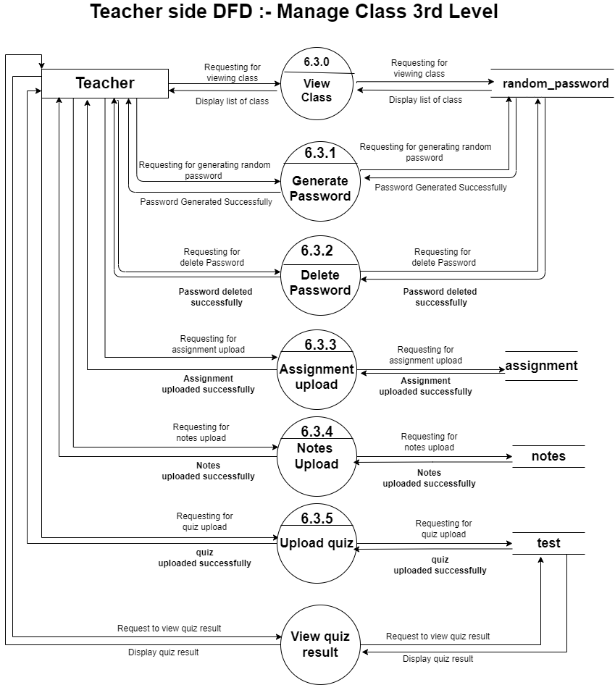
Figure 5.4.1. Teacher Side DFD: Manage Class 3nd Level

ER diagram example :
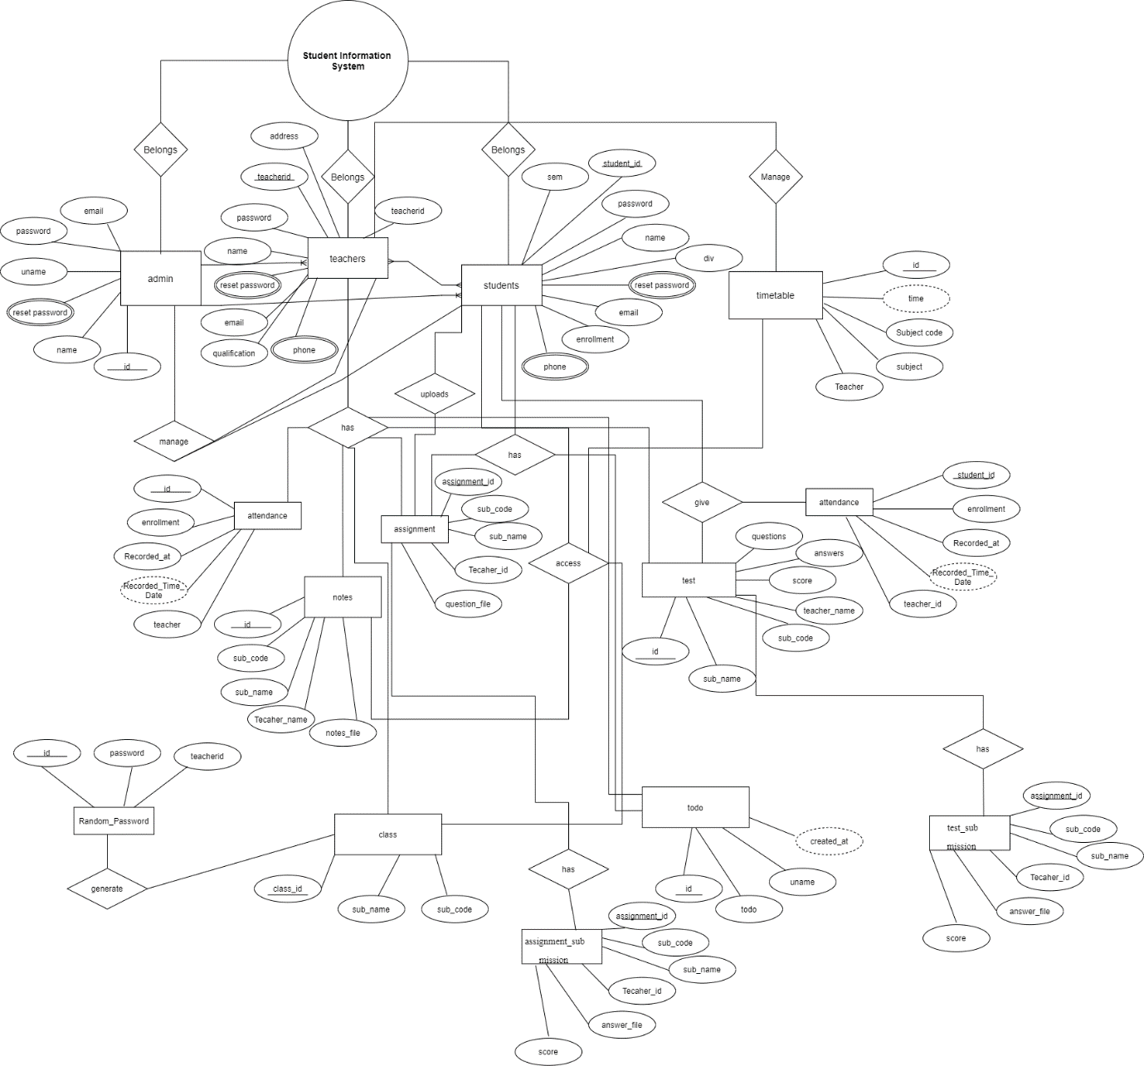
  - Description of E-R Diagram:
This ER (Entity Relationship) Diagram represents the model of Student Information System. The entity-relationship diagram of Student Information System shows all the visual instrument of database tables and the relations between Admin, Teacher, Students, Timetable, Attendance, to-do etc. It used structure data and to define the relationships between structured data groups of Student Information System functionalities.
This ER (Entity Relationship) Diagram represents the model of Student Information System. The entity-relationship diagram of Student Information System shows all the visual instrument of database tables and the relations between Admin, Teacher and Students. It used structure data and to define the relationships between structured data groups of Student Information System functionalities.
The main entities of the Student Information System are Admin, Teacher, Students, Timetable, Attendance, Assignment, Notes, Test, Class, Random_password, Todo etc.
Student Information System belongs to Admin, Teacher and Students entities. In which admin can manage teacher and student’s entities and teacher has attendance, assignments, class, notes, test and todo. In which class can generate random_password. On the other hand students can upload assignment, it has a access on notes, todo and timetable, it can give test and attendance and student entity has assignment and todo list.

✅ Practical: 4 Project Planning and Estimation (W5HH & COCOMO) (Use the W5HH principle to plan a project (Who, What, When, Where, How, how much). Perform software effort estimation using Basic COCOMO Model)

Project Planning and Estimation – Online Food Ordering System

1. W5HH Analysis
W5HH is a simple framework to plan who, what, when, where, how, and how much for the project.
W5HH | Description for Online Food Ordering System
Who | - Project Manager: Overall coordination - Developers: Web/Mobile App, Backend API - UI/UX Designer: Interface design - Database Designer: DB design - Testers: Functional & performance testing - Admin: System management
What | - Develop Online Food Ordering System (Web & Mobile) - Features: Registration/Login, Browse Restaurants, Menu Management, Cart, Order, Payment, Delivery Tracking, Admin Panel
When | Estimated Timeline: 12 weeks - Week 1–2: Requirement Analysis & SRS - Week 3–4: UI/UX Design - Week 5–8: Development (Frontend + Backend + DB) - Week 9–10: Integration & Testing - Week 11–12: Deployment & Documentation
Where | Development: Office / Online Remote Deployment: Web Server / Cloud Platform (AWS / Azure) Access: Customer Mobile App / Web Browser
How | - SDLC Approach: Agile / Iterative - Tools: • Frontend: ReactJS / Android / iOS • Backend: NodeJS / Django / Java Spring • Database: MySQL / PostgreSQL • Version Control: GitHub - Testing: Unit, Integration, User Acceptance Testing
How Much | - Resources: 5–6 team members - Estimated Cost: (Approx based on man-hours & infrastructure) - Hardware/Software: Servers, development tools, cloud services

2. Project Estimation Using COCOMO Model
COCOMO (Constructive Cost Model) estimates effort, time, and cost for software projects based on project size in KLOC (thousands of lines of code).

Step 1: Estimate Project Size
- Assume Web + Mobile OFOS:
  - Frontend: 2000 LOC
  - Backend: 3000 LOC
  - Database scripts: 500 LOC
  - Total ≈ 5500 LOC = 5.5 KLOC

Step 2: Choose COCOMO Model
- Use Basic COCOMO (for small-medium project)
- Project Type: Organic (small team, well-understood application)
Basic COCOMO Formula:
- Effort (Person-Months) = a × (KLOC)^b
- Development Time (Months) = c × (Effort)^d
Coefficients for Organic projects:
Parameter | Value
a | 2.4
b | 1.05
c | 2.5
d | 0.38

Step 3: Calculate Effort
Effort (PM)≈2.4×6.00
Step-by-step calculation:
- 5.5^{1.05}≈5.5×(5.5^{0.05})
- 5.5^{0.05} ≈ 1.086
- 5.5^{1.05}≈5.5×5.5^{0.05}≈5.5×1.086
- Effort ≈ 2.4 × 5.973 ≈ 14.33 Person-Months

Step 4: Calculate Development Time
Time (Months)=2.5×(14.33)^{0.38}
Step-by-step:
- 14.33^{0.38}≈2.74
- Time ≈ 2.5 × 2.74 ≈ 6.85 Months
Approx 7 months for the full project, considering small team efficiency, Agile iterations, and overheads.

Step 5: Team Size Estimation
$Team Size=\frac{Effort}{Development Time} = \frac{14.33}{6.85}$ ≈ 2.1 ≈ 3people
Recommended: 3–5 team members including frontend, backend, and database developers.

3. Summary Table – Project Planning
Parameter | Value
Project Size | 5.5 KLOC
Model Used | COCOMO Basic (Organic)
Effort | 14.33 Person-Months
Development Time | 6.85 Months (~7 months)
Team Size | 3–5 Members
W5HH Highlights | Who: Dev team, Admin What: OFOS features When: 12 weeks (practical plan) Where: Office/Remote How: Agile + Web & Mobile How Much: Cost depends on resources & infrastructure

✅ Key Notes:
- For practical submissions, you can combine W5HH table with COCOMO table.
- You can also adjust KLOC estimates based on detailed module sizing.
- For bigger projects, Intermediate or Detailed COCOMO can be used to include cost drivers.

Project Planning Document – Online Food Ordering System

1. Project Overview
Project Title: Online Food Ordering System (OFOS)
Objective: To design and implement a system for customers to order food online, restaurants to manage orders and menus, and admins to manage users and reports.
Project Type: Web + Mobile Application

2. W5HH Analysis
W5HH | Description
Who | Project Manager, Frontend Developer, Backend Developer, UI/UX Designer, Database Designer, Testers, Admin
What | Features: Registration/Login, Browse Restaurants, Menu Management, Cart, Place Order, Payment Integration, Delivery Tracking, Admin Panel
When | Timeline: 12 Weeks • Week 1–2: Requirement Analysis & SRS • Week 3–4: UI/UX Design • Week 5–8: Development (Frontend + Backend + DB) • Week 9–10: Integration & Testing • Week 11–12: Deployment & Documentation
Where | Development: Office / Remote Deployment: Cloud / Web Server Access: Mobile App & Web Browser
How | SDLC: Agile / Iterative Tools: ReactJS / Android / iOS, NodeJS / Django / Java Spring, MySQL / PostgreSQL, GitHub, Testing Tools
How Much | Team: 5–6 members Cost: Based on man-hours, development tools, server, cloud services

3. Project Estimation – COCOMO Model
Step 1: Project Size
- Frontend: 2000 LOC
- Backend: 3000 LOC
- Database scripts: 500 LOC
- Total ≈ 5500 LOC = 5.5 KLOC
Step 2: COCOMO (Basic, Organic)
Parameter | Value
a | 2.4
b | 1.05
c | 2.5
d | 0.38
Step 3: Effort Calculation
Effort (PM) = 2.4×(5.5)^{1.05} ≈14.33 Person-Months
Step 4: Development Time
Time (Months)=2.5×(14.33)^{0.38} ≈ 6.85 ≈ 7 Months
Step 5: Team Size
$Team Size=\frac{Effort}{Development Time} = \frac{14.33}{6.85}$ ≈ 3–5 members

4. Gantt Chart – Project Timeline (12 Weeks)
Week | Activity
1–2 | Requirement Analysis & SRS Preparation
3–4 | UI/UX Design, Prototype Screens
5–6 | Frontend Development (Customer Module, Restaurant Module)
7–8 | Backend Development & Database Integration
9 | Integration Testing
10 | System Testing & Bug Fixes
11 | Deployment Preparation
12 | Deployment & Documentation Submission
Note: Each week represents one iteration/sprint in Agile approach.

5. Team Allocation
Team Member | Role | Responsibilities
Project Manager | PM | Plan, coordinate, track project progress
Frontend Developer | Developer | Develop web/mobile UI, integrate APIs
Backend Developer | Developer | API development, database connectivity, server-side logic
UI/UX Designer | Designer | Design app interface, user experience workflow
Database Designer | DBA | Design schema, manage database, optimize queries
Tester | QA | Unit, Integration, System, and User Acceptance Testing
Admin | System Admin | Deploy system, monitor performance, maintain servers

6. Resource Requirements
Resource Type | Description
Hardware | Developer PCs, Server/Cloud instance for deployment
Software | IDEs (VS Code, Android Studio), Database (MySQL/PostgreSQL), Version Control (GitHub)
Network | Internet connection, VPN (if remote work)
Miscellaneous | Project documentation tools, Testing tools

7. Cost Estimation (Optional)
Item | Cost Estimate (USD)
Human Resources | 5–6 members × 7 months × avg salary per PM ≈ 20,000–25,000
Servers / Cloud | Deployment & hosting ≈ 200–500
Tools / Software | IDEs, Database, Testing Tools ≈ 300
Miscellaneous | Documentation, contingency ≈ 200
Total Estimate | ~21,000–26,000

8. Summary
- W5HH ensures project scope, team, methods, and resources are well-defined.
- COCOMO estimation provides effort, time, and team size for planning.
- Gantt chart outlines weekly tasks for scheduling.
- Team allocation defines responsibilities and accountability.
- Ready for development, testing, and deployment with clear timeline and resources.

✅ Practical: 5 Risk Management and Quality Planning Report (Identify at least 5 major project risks, analyze their impact and probability, and propose mitigation strategies. Include a short quality plan covering QA and QC activities).

Risk Management and Quality Planning Report – Online Food Ordering System

1. Introduction
The Online Food Ordering System (OFOS) allows customers to browse restaurants, place orders, make payments, and track deliveries. Restaurants can manage menus and orders, while admins manage users and reports.
This report identifies project risks, evaluates their impact, and defines quality planning to ensure a reliable, maintainable, and efficient system.

2. Risk Management
Risk management involves identifying, analyzing, and mitigating risks throughout the software development lifecycle.

2.1 Risk Identification
Risk ID | Risk Description | Category
R1 | Delay in requirement gathering | Schedule Risk
R2 | Incorrect or incomplete SRS | Requirement Risk
R3 | Development delays due to unfamiliar technology | Technical Risk
R4 | Server downtime / hosting issues | Operational Risk
R5 | Payment gateway integration failure | Technical / Financial Risk
R6 | Security vulnerabilities (data breach, SQL injection) | Security Risk
R7 | Poor UI/UX leading to low adoption | User Acceptance Risk
R8 | Data loss due to database failure | Operational Risk
R9 | Communication gaps in team (remote work) | Management Risk
R10 | Regulatory compliance issues (PCI DSS, GDPR) | Legal / Compliance Risk

2.2 Risk Analysis and Mitigation
Risk ID | Probability | Impact | Mitigation Strategy
R1 | Medium | High | Conduct regular meetings, clear timelines, monitor progress
R2 | Medium | High | Perform peer reviews of SRS, involve stakeholders
R3 | Medium | Medium | Provide training, adopt Agile iterative development
R4 | Low | High | Use reliable cloud servers, maintain backup servers
R5 | Medium | High | Test payment integration thoroughly, use sandbox mode
R6 | Medium | High | Implement secure coding practices, encryption, regular security testing
R7 | Medium | Medium | Conduct usability testing, prototype feedback
R8 | Low | High | Implement regular database backups, replication
R9 | Medium | Medium | Use project management tools (Jira, Trello), daily standups
R10 | Low | High | Consult legal experts, follow compliance guidelines

2.3 Risk Monitoring
- Maintain a Risk Register for tracking risks, status, and mitigation.
- Conduct weekly risk review meetings.
- Assign risk owners for each critical risk.

3. Quality Planning
Quality planning ensures the software meets functional and non-functional requirements, is reliable, maintainable, and satisfies end-users.

3.1 Quality Objectives
Objective | Description
Functionality | All features (registration, menu management, ordering, payment, tracking) must work correctly.
Reliability | System should handle 100+ concurrent users with minimal downtime.
Usability | Intuitive UI/UX, responsive design for web and mobile.
Security | Secure login, encrypted data storage, secure payment transactions.
Performance | Fast response time (<3 seconds for key actions like browsing menu or placing order).
Maintainability | Modular design using MVC/OOA approach, clear code documentation.
Compliance | Follow PCI DSS for payments, GDPR for user data privacy.

3.2 Quality Assurance (QA) Activities
QA Activity | Description
Code Review | Peer review of all code modules to detect errors early.
Unit Testing | Test individual components (frontend, backend, database) separately.
Integration Testing | Verify combined modules interact correctly.
System Testing | Full system test for end-to-end functionality.
User Acceptance Testing (UAT) | End-users test the system for usability and functionality.
Security Testing | Test for vulnerabilities, penetration testing.
Performance Testing | Load and stress testing to measure system performance.

3.3 Quality Standards and Metrics
Metric | Target
Defect Density | < 1 defect per 1000 LOC
Test Coverage | ≥ 90% code coverage in unit tests
Response Time | ≤ 3 seconds for main actions
Availability | ≥ 99% uptime for web/mobile
User Satisfaction | ≥ 85% positive feedback from UAT

3.4 Tools for Quality Assurance
- Version Control: GitHub / GitLab
- Testing Tools: Selenium, JUnit, Postman
- Project Management: Jira / Trello
- Security Testing: OWASP ZAP, Burp Suite
- Performance Testing: Apache JMeter

4. Conclusion
- Proper risk management minimizes potential delays, cost overruns, and technical failures.
- Effective quality planning ensures the OFOS system meets user expectations, is secure, reliable, and maintainable.
- Combining risk monitoring and quality assurance creates a robust software development process ready for deployment.

✅ Practical: 6 Use Case Modeling and Diagrams (Prepare Use Case Descriptions and corresponding Use Case Diagrams for the SRS developed earlier. Identify main actors, use cases, and relationships).

Here’s a complete Use Case Modeling and Diagrams package for your Online Food Ordering System (OFOS), combining use case descriptions and a graphical UML Use Case Diagram.

1. Main Actors
Actor | Description
Customer | End-user who browses restaurants, places orders, makes payments, and tracks delivery.
Restaurant Staff | Manages menu, receives and processes orders.
Delivery Person | Updates order status during delivery.
Admin | Manages system users, restaurants, and generates reports.

2. Use Case Descriptions

UC01 – User Registration
Field | Description
Use Case ID | UC01
Actor | Customer
Pre-condition | User does not have an account
Post-condition | New account created
Description | Customer enters personal details to register for the system
Normal Flow | Open registration → enter details → validate → create account → confirmation displayed
Alternate Flow | Email already exists → show error
Exception Flow | Network failure → registration fails

UC02 – User Login
Field | Description
Use Case ID | UC02
Actor | Customer
Pre-condition | Account exists
Post-condition | User authenticated
Normal Flow | Enter email/password → system validates → login successful
Alternate Flow | Wrong password → show error
Exception Flow | Account locked after multiple failed attempts

UC03 – Browse Restaurants & Menu
Field | Description
Use Case ID | UC03
Actor | Customer
Pre-condition | Logged in
Post-condition | Customer views restaurant and menu
Normal Flow | Select restaurant → view menu → apply filters
Alternate Flow | No restaurants available → show message

UC04 – Add Item to Cart
Field | Description
Use Case ID | UC04
Actor | Customer
Pre-condition | Menu loaded
Post-condition | Item added to cart
Normal Flow | Select item → choose quantity → add to cart
Alternate Flow | Item unavailable → show message

UC05 – Place Order & Payment
Field | Description
Use Case ID | UC05
Actor | Customer
Pre-condition | Cart contains items
Post-condition | Order placed and recorded
Normal Flow | Review cart → choose payment → confirm order → system records order → sent to restaurant
Alternate Flow | Payment fails → retry
Exception Flow | Restaurant offline → order canceled

UC06 – Accept/Reject Order
Field | Description
Use Case ID | UC06
Actor | Restaurant Staff
Pre-condition | Order submitted
Post-condition | Order status updated
Normal Flow | Receive order → accept/reject → system updates status
Alternate Flow | Rejected → notify customer

UC07 – Update Order Status (Delivery)
Field | Description
Use Case ID | UC07
Actor | Delivery Person
Pre-condition | Order accepted
Post-condition | Status updated
Normal Flow | Pick up order → update status (Out for delivery → Delivered)
Exception Flow | Delivery failed → mark as failed

UC08 – Manage Menu
Field | Description
Use Case ID | UC08
Actor | Restaurant Staff
Pre-condition | Restaurant active
Post-condition | Menu updated
Normal Flow | Add/update/delete menu items → save changes
Exception Flow | Invalid input → show error

UC09 – Admin Operations
Field | Description
Use Case ID | UC09
Actor | Admin
Pre-condition | Admin logged in
Post-condition | System data updated
Normal Flow | Manage users/restaurants → generate reports
Exception Flow | Unauthorized access blocked

UC10 – Track Order
Field | Description
Use Case ID | UC10
Actor | Customer
Pre-condition | Customer has active order
Post-condition | Customer views order status
Normal Flow | Open “Track Order” → system fetches status → display
Exception Flow | Network issue → cannot fetch status

3. Use Case Diagram (Graphical)
Diagram Description:
- Actors: Customer, Restaurant Staff, Delivery Person, Admin
- Customer → Registration/Login, Browse Menu, Add to Cart, Place Order, Payment, Track Order
- Restaurant Staff → Accept/Reject Order, Manage Menu
- Delivery Person → Update Order Status
- Admin → Manage Users/Restaurants, Generate Reports

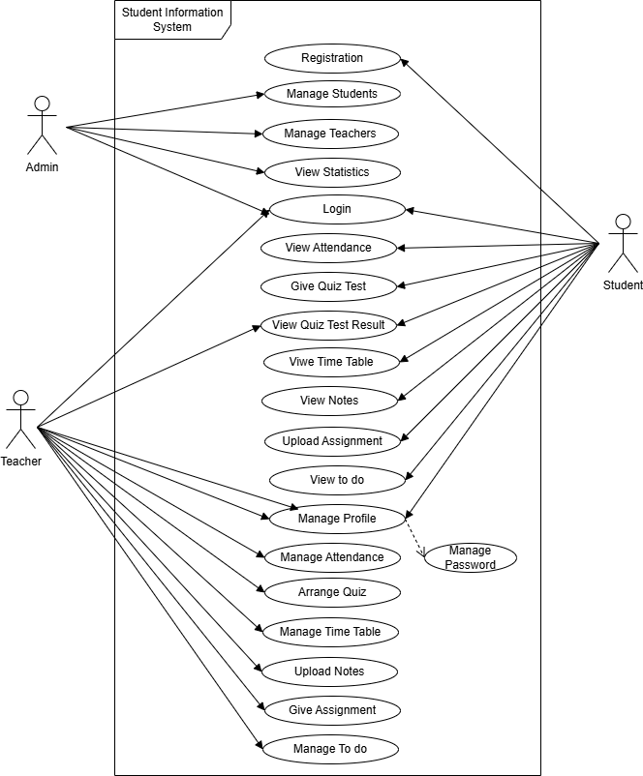

✅ Practical: 7 Design UML Diagrams (Class, Sequence, and Activity).

Class Diagram:
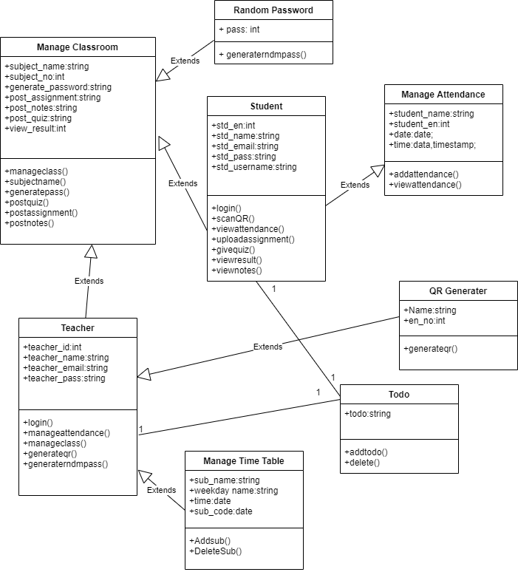

Activity Diagram :
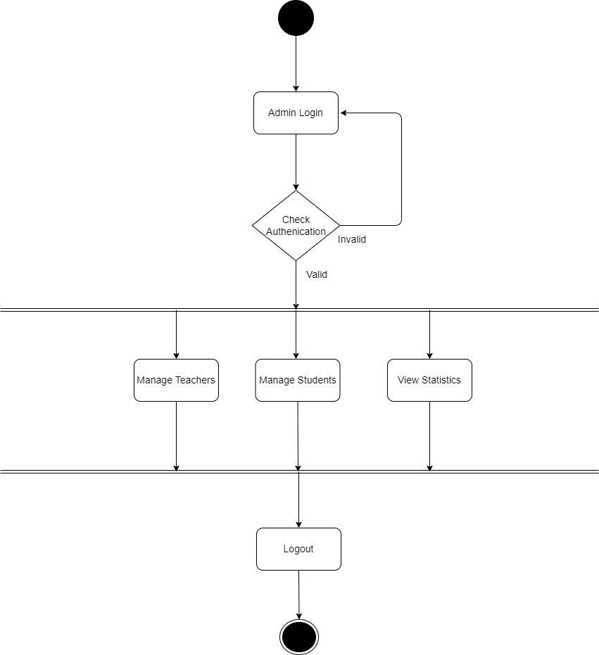
Admin Activity Diagram

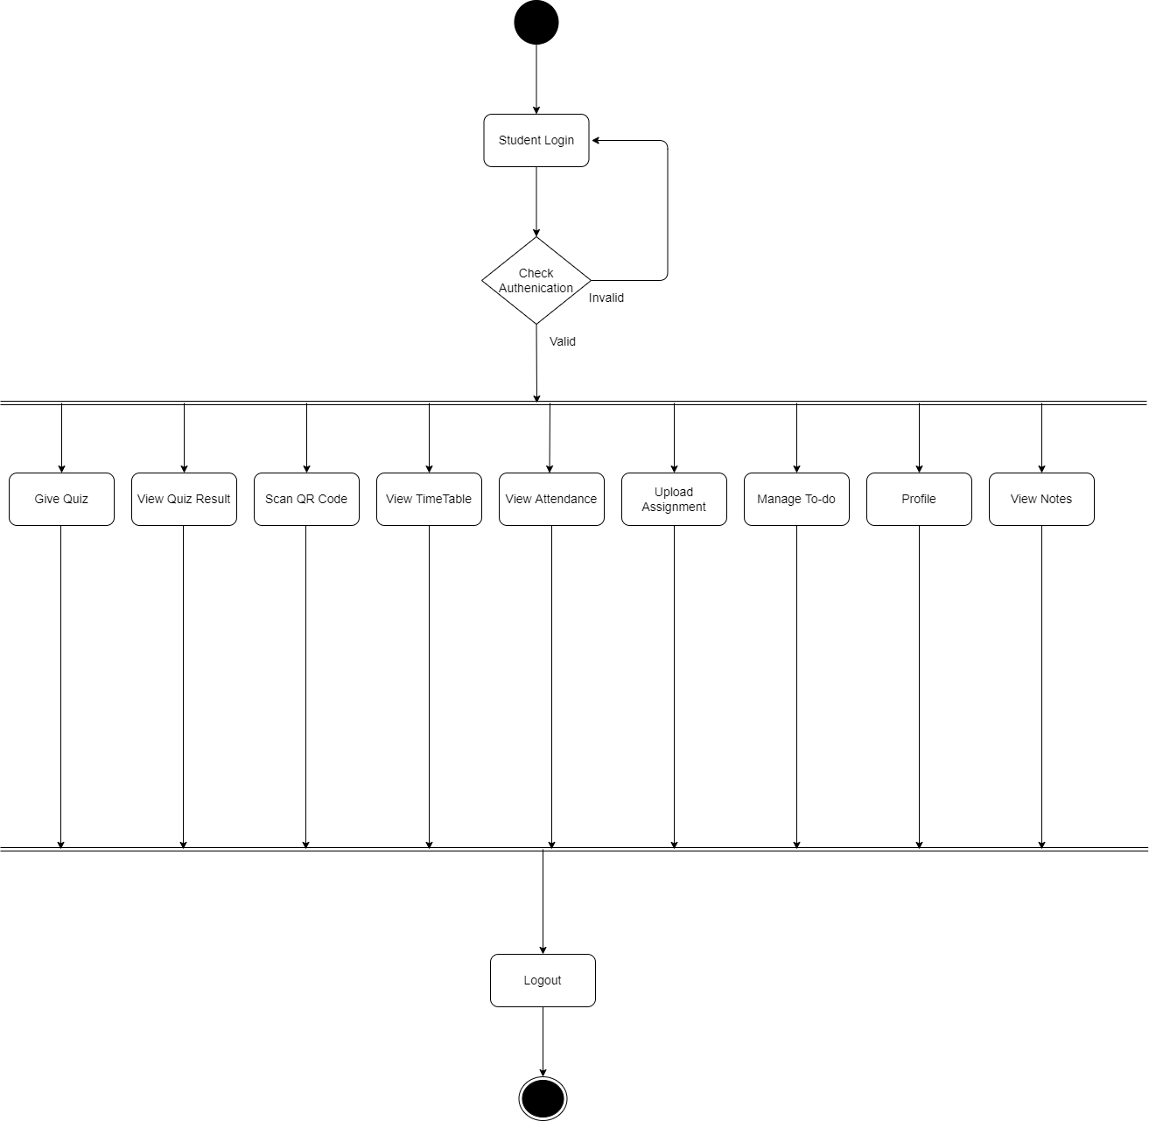
Student Activity Diagram

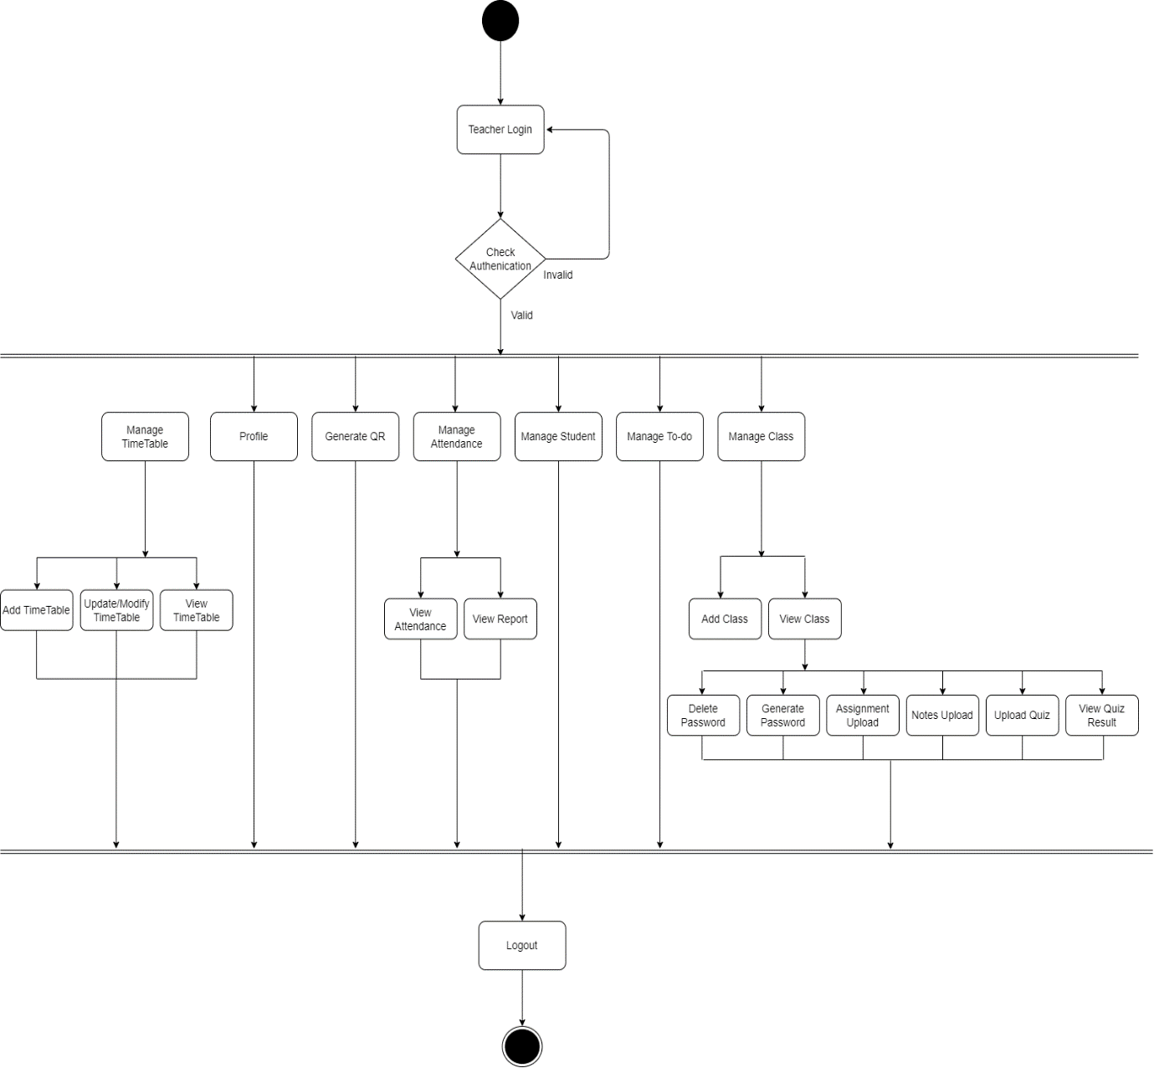
Teacher Activity Diagram
Sequence Diagram :

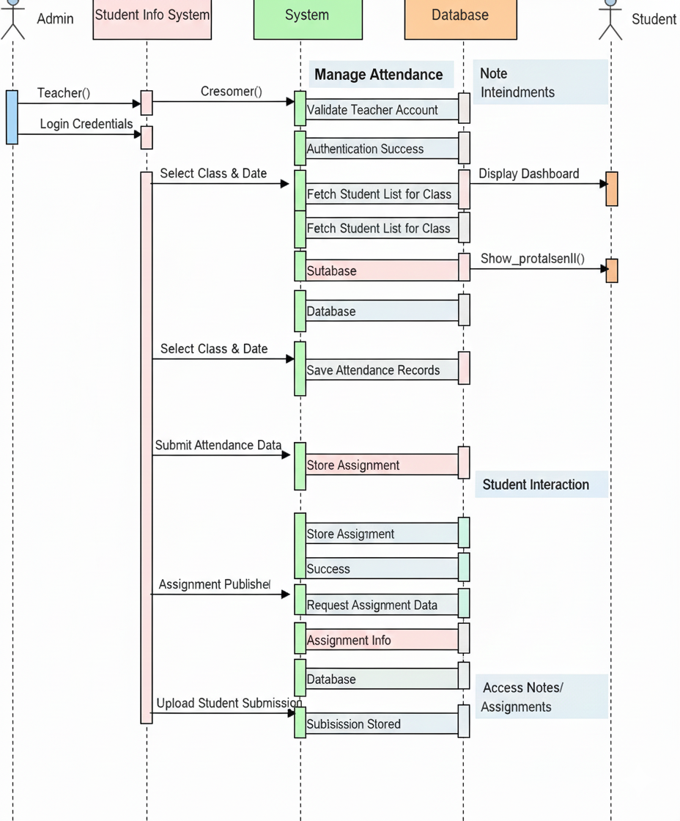

✅ Practical: 8 Software Testing – Test Case Design and Verification (Write at least 10 test cases for one module using Black Box and White Box techniques. Indicate input, expected output, and actual output.)
Module: Login Function for an Online Banking System
Functionality: The user enters a username and password to log in. If the credentials are correct, access is granted; otherwise, an error message is displayed.

Black Box Test Cases (Functional Testing)
Here, we focus on inputs and outputs, without considering the internal code.
TC  No | Test Case Description | Input | Expected Output | Actual Output | Pass  / Fail
1 | Valid login credentials | Username: user1, Password: Pass@123 | Login successful, redirect to dashboard | - | -
2 | Invalid password | Username: user1, Password: wrongpass | Error message: “Invalid username or password” | - | -
3 | Invalid username | Username: wronguser, Password: Pass@123 | Error message: “Invalid username or password” | - | -
4 | Empty username | Username: , Password: Pass@123 | Error message: “Username cannot be empty” | - | -
5 | Empty password | Username: user1, Password: | Error message: “Password cannot be empty” | - | -
6 | SQL Injection attempt | Username: ' OR 1=1 -- , Password: any | Error message: “Invalid username or password” | - | -
7 | Special characters in username | Username: user!@#, Password: Pass@123 | Error message: “Invalid characters in username” | - | -
8 | Password case sensitivity | Username: user1, Password: pass@123 | Error message: “Invalid username or password” | - | -
9 | Maximum length username | Username: 50-char string, Password: Pass@123 | Login successful or error if max limit exceeded | - | -
10 | Maximum length password | Username: user1, Password: 50-char string | Login successful or error if max limit exceeded | - | -

White Box Test Cases (Structural / Code-Based Testing)
Here, we test internal logic, branches, and loops. Assume the login module code contains:
if(username == "") { error("Username cannot be empty"); }
else if(password == "") { error("Password cannot be empty"); }
else if(validateUser(username, password)) { redirectToDashboard(); }
else { error("Invalid username or password"); }
TC No | Test Case Description | Input | Expected Output | Path Tested
1 | Empty username | Username: , Password: Pass@123 | Error: Username cannot be empty | if(username=="")
2 | Empty password | Username: user1, Password: | Error: Password cannot be empty | else if(password=="")
3 | Valid credentials | Username: user1, Password: Pass@123 | Redirect to dashboard | else if(validateUser)
4 | Invalid username | Username: wrong, Password: Pass@123 | Error: Invalid username or password | else branch
5 | Invalid password | Username: user1, Password: wrong | Error: Invalid username or password | else branch
6 | Both username and password empty | Username: , Password: | Error: Username cannot be empty | First if takes precedence
7 | SQL Injection attempt | Username: ' OR 1=1 -- , Password: any | Error: Invalid username or password | validateUser() branch
8 | Case sensitivity test | Username: User1, Password: pass@123 | Error: Invalid username or password | validateUser() branch
9 | Boundary test for username length | Username: 50-char string, Password: Pass@123 | Pass or error based on max length | Input validation path
10 | Boundary test for password length | Username: user1, Password: 50-char string | Pass or error based on max length | Input validation path

✅ Notes:
- Black Box focuses on expected behavior regardless of code paths.
- White Box focuses on testing all possible branches and paths in the code.
- Actual output should be filled after executing the test cases.

✅ Practical: 9 Software Testing Levels and Execution Report (Demonstrate different testing levels (Unit, Integration, System, Acceptance) conceptually using one module. Prepare a short testing report).

Module: Login Function for Online Banking System
Functionality: User enters a username and password. If correct, access is granted; otherwise, an error message is displayed.

1. Testing Levels

1. Unit Testing
- Purpose: Test individual components or functions of the module.
- Scope in Login Module:
  - validateUsername(username) → Checks if username is non-empty and valid.
  - validatePassword(password) → Checks password constraints.
  - authenticateUser(username, password) → Checks credentials in the database.
- Example Test Cases:
  - Username empty → should return error.
  - Password empty → should return error.
  - Correct username and password → should authenticate successfully.

2. Integration Testing
- Purpose: Test interactions between integrated modules.
- Scope in Login Module:
  - Login module integrated with Database Module.
  - Verify correct fetching and matching of user credentials.
- Example Test Cases:
  - Enter valid credentials → system retrieves user data from DB → login succeeds.
  - Enter invalid credentials → system checks DB → returns error.

3. System Testing
- Purpose: Test the complete system to ensure it meets requirements.
- Scope in Login Module:
  - Full banking system login workflow including UI, backend authentication, and security checks.
- Example Test Cases:
  - Login with valid credentials → redirect to dashboard.
  - Login with SQL injection attempt → system rejects input.
  - Login with incorrect credentials → displays proper error message.

4. Acceptance Testing
- Purpose: Ensure system meets business requirements and is ready for end users.
- Scope in Login Module:
  - Conducted by end users or stakeholders.
- Example Test Cases:
  - Users can log in successfully with correct credentials.
  - System prevents unauthorized access.
  - System displays user-friendly error messages for invalid inputs.

2. Sample Testing Execution Report (Short Format)
Test Level | Test Case Description | Input | Expected Output | Actual Output | Status
Unit | Empty username | Username: , Password: Pass@123 | Error: Username cannot be empty | Error: Username cannot be empty | Pass
Unit | Empty password | Username: user1, Password: | Error: Password cannot be empty | Error: Password cannot be empty | Pass
Integration | Valid credentials, DB connected | Username: user1, Password: Pass@123 | Login successful | Login successful | Pass
Integration | Invalid credentials, DB connected | Username: user1, Password: wrong | Error: Invalid username or password | Error: Invalid username or password | Pass
System | SQL injection attempt | Username: ' OR 1=1 -- , Password: any | Error: Invalid username or password | Error: Invalid username or password | Pass
System | Valid credentials | Username: user1, Password: Pass@123 | Redirect to dashboard | Redirect to dashboard | Pass
Acceptance | End user login | Username: user1, Password: Pass@123 | User can access dashboard | User can access dashboard | Pass
Acceptance | Error handling | Username: , Password: | User-friendly error message | User-friendly error message | Pass

✅ Notes:
- Execution Report shows each test case’s expected vs actual output.
- Status is marked as Pass/Fail after testing.
- This format is concise and suitable for documentation purposes.

✅ Practical: 10 Demonstration of CASE Tools (Explore a CASE tool such as StarUML, Visual Paradigm, or Rational Rose. Demonstrate how it supports software design (UML creation, code generation, or documentation).

1. Introduction to CASE Tools
CASE (Computer-Aided Software Engineering) tools help software developers model, design, and document software systems efficiently. They provide:
- UML diagram creation (Class, Sequence, Activity, etc.)
- Code generation (from UML to programming languages)
- Documentation support (export diagrams, reports)
- Consistency checks (ensures model correctness)
Popular CASE tools include: StarUML, Visual Paradigm, Rational Rose, Enterprise Architect.

2. Demonstration Using StarUML

Step 1: Create a New Project
- Open StarUML.
- Click File → New Project → UML.
- Choose the UML 2.x model.
- Name your project, e.g., OnlineBankingSystem.

Step 2: Create UML Diagrams

A. Class Diagram
- Add a Class Diagram to the model.
- Create classes like User, Login, Account.
- Add attributes and methods:
  - User: username, password
  - Login: validateUser(), authenticateUser()
  - Account: accountNumber, balance
- Define relationships:
  - Association between User and Account.
  - Dependency between Login and User.

B. Sequence Diagram
- Add a Sequence Diagram.
- Illustrate the login process:
  - User → Login → Database → Login → User
- Show messages like enterCredentials(), validateUser(), displayDashboard().

C. Activity Diagram
- Add an Activity Diagram for login flow.
- Define activities:
  - Enter username & password → Validate → Authenticate → Success/Error message.
- Use decision nodes for valid/invalid credentials.

Step 3: Code Generation
- Select a class (e.g., User) → Right-click → Generate Code → Choose Language (Java, C#, Python, etc.)
- StarUML generates skeleton code with class names, attributes, and methods.
- Developers can then add logic to these generated classes.

Step 4: Documentation and Export
- Export diagrams:
  - File → Export → Diagram as Image (PNG, SVG) for reports.
- Generate HTML or PDF reports for project documentation.
- Helps maintain traceability between requirements, design, and implementation.

3. Benefits of Using StarUML (or any CASE tool)
- Speeds up software design with drag-and-drop UML modeling.
- Maintains consistency between diagrams and code.
- Supports team collaboration by sharing models.
- Useful for educational, professional, and documentation purposes.

1. Project Name: OnlineBankingSystem

2. UML Diagrams to Include

A. Class Diagram
Classes and Attributes/Methods:
Class | Attributes | Methods
User | username, password, email | getUsername(), getPassword()
Login | - | enterCredentials(), validateUser(), authenticateUser()
Account | accountNumber, balance | getBalance(), deposit(), withdraw()
Relationships:
- Association: User → Account
- Dependency: Login → User

B. Sequence Diagram (Login Process)
Participants: User, Login, Database
Flow:
- User → Login: enterCredentials()
- Login → User: validateUser()
- Login → Database: authenticateUser()
- Database → Login: authenticationResult
- Login → User: displayDashboard() / displayError()

C. Activity Diagram (Login Flow)
Activities & Decisions:
- Start → Enter Username & Password → Decision: Are credentials valid?
  - Yes → Redirect to Dashboard → End
  - No → Display Error → End

3. Code Generation (Optional Demo)
- From the Class Diagram, generate skeleton code in Java/Python/C#.
- Example: User.java with class, attributes, and empty methods.

4. Documentation & Export
- Export each diagram as PNG or SVG for reports.
- Generate HTML or PDF report from StarUML to show project structure.

5. Deliverables for Submission
- StarUML .mdj project file (editable in StarUML).
- PNG/SVG diagrams (Class, Sequence, Activity).
- Optional: Generated skeleton code.
- Optional: HTML/PDF documentation exported from StarUML.

